Problem (1)

Airports Routes

**Max = 915**

**Min = 1**

**Mean = 19.84**

**Std = 53.50**

**Len = 3409**

Data:

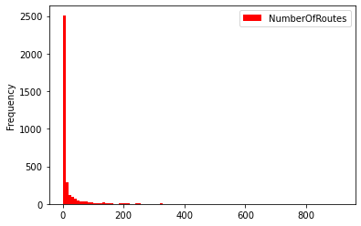

(A) Power Law

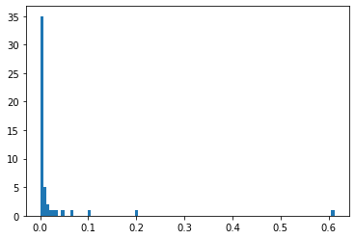

**Alpha = 1.61**

(B) Exponential

**Lambda = .05**

(C) Uniform

**Parameters**

**Range = [1,915]**

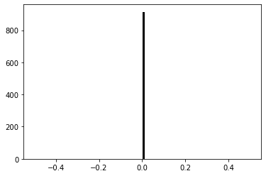

(D) Normal

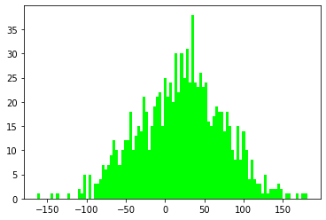

**Mean = 19.84**

**Std = 53.50**

Questions

Airport Routes

Which distribution do you think the data follows and why?

From the graphs that have been created using the airport routes data it seems to me that the distribution it might follow is the power law. Considering the mean is 19.84 concluding that majority of the airports have mostly only 20 routes to choose from. The max is 915 which made the graph skewed right hard since only one airport can have 915 routes.

Movies Votes

**Max = 8.5**

**Min = 1.9**

**Mean = 6.22**

**Std = .89**

**Len = 4392**

Data:

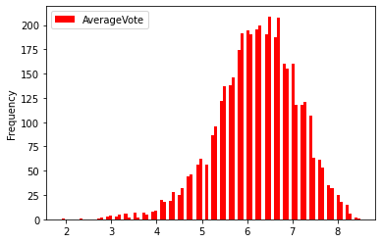

(A) Power Law

**Alpha = 1.85**

(B) Exponential

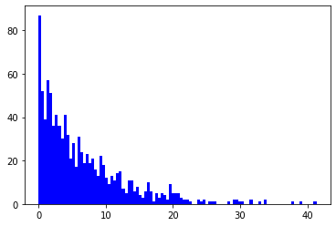

**Lambda = .16**

(C)Uniform

**Parameters**

**Range = [1.9,8.5]**

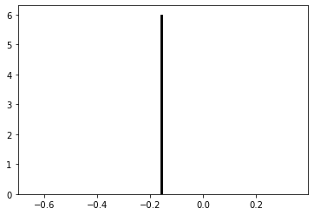

(D) Normal

**Mean = 6.22**

**Std = .89**

Questions

Movies

Which distribution do you think the data follows and why?

From the graphs that have been created using the movies data it seems to me that the distribution it might follow is the normal. Considering the data is a list of movies rated from 1 to 10 this graph proves to make the most sense. While uniform and power law don’t even play a role and exponential is skewed right which would mean that most of the movies are hard rated very low which seems very unlikely.

Problem (2)

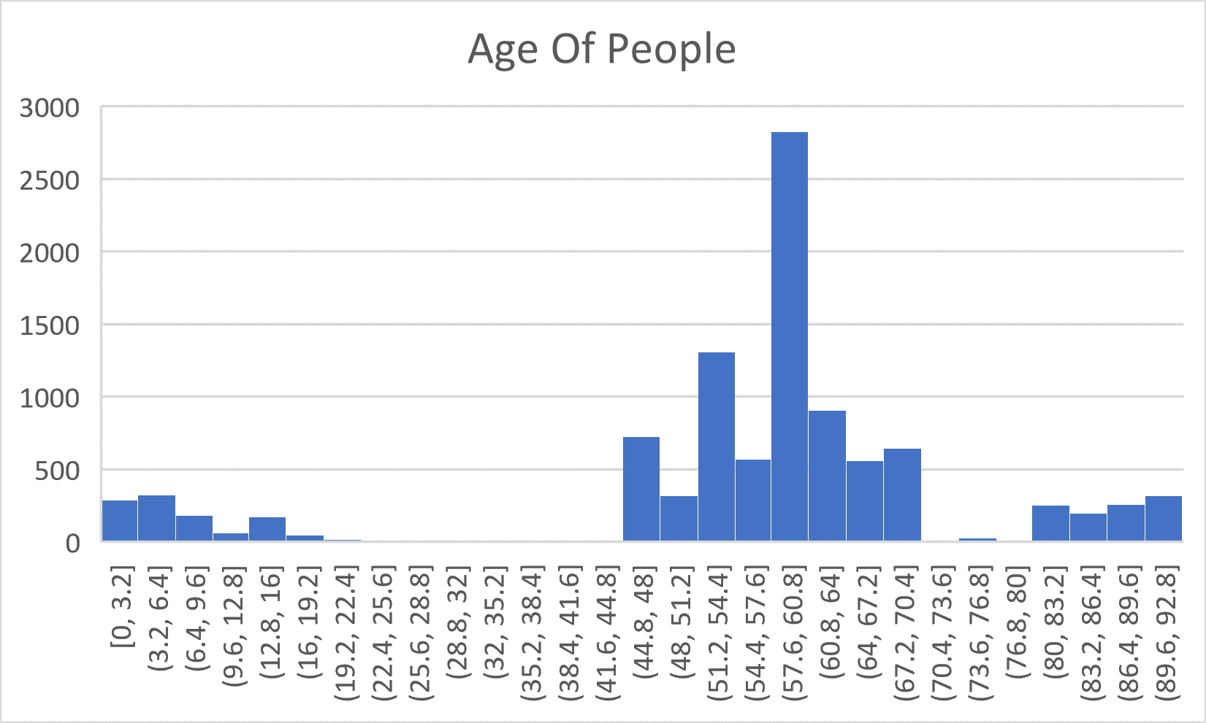

Question

Explain what the integers correspond to in real life?

Assuming majority of the date are form the 2000’s century.

The data shows the years from today of people who were born and died. The number of years they were alive from today. The graph is not uniform considering the chart is a little skewed left meaning a good amount of people have lived above the age of 50. The graph follows a more of a normal distribution. This is due to the graph forming a kind of bell shape to it when looked at.